Running head: COMPARATIVE ANALYSIS

**Comparative Analysis of Coarse-Grained and Atomistic Molecular Dynamics Simulations of DPCE Lipid Membranes**

Submitted by

# Abstract

We strive to unravel the complex interplay and properties of lipid membranes, key components of biological constructs, through the valuable tool of molecular dynamics simulations. Our research article, "Comparative Analysis of Coarse Grained and Atomistic Molecular Dynamics Simulations of Ceramide DPCE Lipid Membranes," sheds light on the actions of lipid bilayers made from ceramides, notably DPCE (2,3-dihydroxypropyl dihydroceramide). The objective is to gain deeper insights into the bio-physical traits of ceramide membranes using DPCE, a typical ceramide molecule. We carry out molecular dynamics simulations on hydrated DPCE lipid bilayers at a raised temperature of 368 K. This aims to delve into the bilayer properties a tad above its main phase transition. Our simulations involve the use of 128 lipids, spread out evenly across two leaflets, to simulate­ a section of a lipid membrane.

We've planned and implemente­d the simulation of DPCE ceramide bilayer properties with precision and detail. By closely examining the structure and movement of these lipid bilayers, our goal is to enhance our comprehension of membrane behaviour characteristic of DPCE ceramide. This research adds to the wider understanding of lipid membrane motion, highlighting the biophysical features of membranes reliant on ceramide, using DPCE as a standard model for ceramides. These findings have potential implications for the comprehension of cellular activities and diseases tied to abnormalities in lipid membrane­ function.

## Objective

This research strives to decode the­ characteristics of ceramide membranes, using DPCE as a sample molecule, by examining them via simplified and detailed molecular dynamics simulations. By comparing, we aim to identify the benefits and drawbacks of these methods in recording the dynamic traits of ceramide membranes.

## Setting Up the Environment

* Used a Linux-based system known for its competence in scientific computing.
* Set up crucial molecular dynamic simulation programs like GROMACS or NAMD, making sure they work well with ceramide membranes, especially DPCE.

## System Setup

* Built input files that detail the ceramide membrane system which consists of various ceramide types, starting arrangements, force field aspects, and simulation plans.
* Made sure consistency in the system layout across both atomistic and coarse-grained simulations to enable significant comparisons.

## Running Simulations

* Implemented molecular dynamics simulations using the specified software tools, following relevant simulation guidelines.
* Established simulation se­ttings including pressure, temperature, integration time step, and simulation duration to accurately mirror DPCE membrane dynamics.

## Analysis

* Gathered key specifics such as lipid movement rates, membrane flexibility, lipid space, and thickness from simulation paths.
* Performed a data analysis to compare the functioning of ceramide membranes in detaile­d and rough simulations.

## Visualisation

* Employed sophisticated tools for visualizing molecules, like VMD or PyMOL, to depict the results of simulations.
* Created striking visual interpretations that revealed the structure, movement, and standout features of ceramide membranes.

## Comparative Interpretation:

* Analyzed the results of simulations through the lens of chosen modelling techniques.
* Debated and compared the witnessed functions of ceramide membranes in atomistic compared to coarse-grained simulations, outlining the assets and drawbacks of each tactic.

# Conclusion and Insights

* We distilled conclusions from juxtaposing detailed and large-scale observations of ceramide membrane simulations, with DPCE as a point of reference.
* We shed light on how effectively each model uncovers the interactions in ceramide membranes. We also mapped out possible repercussions for subsequent investigations in the field of membrane biophysics and associated areas.

**Table of Contents**

Abstract 2

Objective 2

Setting Up the Environment 3

System Setup 3

Running Simulations 3

Analysis 4

Visualisation 4

Comparative Interpretation: 4

Conclusion and Insights 4

Introduction 9

Methods 16

System Preparation 16

Molecular Dynamics Simulations 20

Employing Equilibration Parameters for Production Simulations 20

System Equilibration 21

Data Analysis 22

Membrane Analysis - Area Per Lipid (APL) 22

Membrane Analysis – Compressibility Modulus (κA) 22

Analysis – (Density Profiles) 23

Analysis (Bilayer Thickness) 24

Analysis – (Tail Order) 24

Comparative Analysis of Atomistic and Coarse-Grained Simulations 25

Atomistic Simulations 26

Strengths 27

Limitations 28

Structural Features and Membrane Properties in Atomistic Simulations 28

Coarse-Grained Simulations (MARTINI) 29

Strengths 30

Limitations 31

Visualization 32

Atomic simulation Result 33

Visualization 35

Simulation 1 35

Simulation 2 35

Simulation 3 35

Atomic Analysis -Based on Final Simulation 41

Coarse-Grained Simulation Result 44

Analysis Based on Final Simulation 47

Interpretation 50

Area per Lipid (APL) 50

Bilayer Thickness 51

Discussion 51

Area per Lipid (APL) 51

Critical Review 52

Bilayer Thickness 52

Critical Review 53

Tail Order Parameter 53

Critical Review 53

Recommendations 59

Conclusion 61

Acknowledgement 62

References 64

# Introduction

Ceramides are lipids present in skin cells, making up 30% to 40% of the outer layer of the pores and skin, called the epidermis. They play a crucial position in preserving pores and skin moisture and inhibiting the penetration of pathogens into the body. Age-associated reduction in ceramide tiers in the skin can bring about dehydration and pores and skin troubles like dryness and inflammation. Ceramides play a vital position in preserving the integrity of the skin's barrier feature, serving as the number one shielding mechanism towards outside pollutants and pollution. Additionally, they provide aid for mind development and cellular function. Ceramides are regularly integrated into skincare merchandise such as ceramide moisturizers, creams, serums, and toners, with the primary goal of enhancing pores and skin fitness via the augmentation of ceramide stages. There is a difference between herbal and artificial ceramides, in which natural ceramides are determined inside the outer layers of the skin, as well as in animals which include cows and vegetation like soy. Pseudoceramides, also called artificial ceramides, are artificially manufactured. The utilization of synthetic ceramides in skin care products is more general because of their absence of contaminants and better stability in comparison to natural ceramides. Ceramides include sphingosine, which is a carbon atom chain that is related to an amino acid. Ceramides are synthesized through the combination of various fatty acids with multiple types of sphingosines. Ceramides are classified into 12 classes, namely ceramides 1 to 12, based on the specific arrangement of sphingosine and the fatty acid it forms a bond with.

Lipid membranes are essential structural elements in organic systems, serving as an essential function in establishing compartmental boundaries and allowing diverse crucial cellular processes. Ceramides, a form of lipid, are exquisite for their enormous effect on cell body structure and membrane characteristics within the big selection of lipids present in membranes. This looks at employing a hybrid method, incorporating each coarse-grained and atomistic simulation within the framework of molecular dynamics. One of the primary objectives is to behaviour a radical examination of lipid membranes inclusive of ceramide, with a particular consciousness on DPCE (2, 3-dihydroxy propyl). The subclass of sphingolipids known as ceramides plays a critical role in the regulation of cellular signalling and apoptosis. They play a vital role as essential components of cellular membranes [1].

Lipids are a diverse group of natural compounds that include fat, oils, hormones, and specific membrane materials. The categorization of these compounds is based on their limited interaction with water. Triglycerides, a specific type of lipid, are stored as fat in adipose cells. These cells function as a storage site for energy and also offer thermal insulation. Certain lipids, such as steroid hormones, function as chemical mediators that allow for communication between cells, tissues, and organs. Additionally, some lipids facilitate signalling between biochemical systems within a single cell. Cell and organelle membranes are characterized by their microscopically thin composition, consisting of two layers of phospholipid molecules. Membranes serve the purpose of segregating individual cells from their surrounding environments and dividing the cell interior into distinct compartments that are responsible for specific functions. The compartmentalizing function is of such significance that membranes, along with the lipids that constitute them, must have played a crucial role in the emergence of life.

Biological membranes based on ceramide (CER) are employed in both experimental and simulation settings as simplified model systems for the skin barrier. Molecular dynamics investigations have predominantly centred on the simulation of preassembled structures through the utilization of atomistically intricate models of CERs. However, these models impose constraints on the system sizes and timescales that can be practically investigated, thereby rendering them inadequate for the examination of specific phenomena, such as self-assembly into the bilayer and lamellar superstructures. In this report, we present the creation of a coarse-grained (CG) model for CER NS, which is the most prevalent CER found in the human stratum corneum Although the lipid composition in human SC is understood, the relationship between lipid composition, structure, and barrier function is still not well understood. Comprehending these associations is crucial for creating efficient skin models for toxicology evaluation and the advancement of transdermal drug delivery, as well as for devising efficacious treatments for skin ailments. The utilization of molecular simulation techniques in the investigation of SC lipid systems presents an opportunity to explore the interrelationships among lipid composition, structure, and barrier function. Simulation facilitates the direct observation and deliberate manipulation of the molecular entities within the system. Molecular simulations have been widely employed to gain a deeper comprehension of the structure, phase behaviour, thermodynamics, and transmembrane permeability of phospholipid-based bilayer systems.

Nevertheless, the investigation of CER-based bilayers has been less extensive compared to phospholipid-based systems, mainly due to the intricate structure of the lipid arrangement and the absence of precise atomistic force fields, a concern that has been recently resolved. The atomistic simulations conducted on CER bilayer structures have yielded valuable insights into lipid interactions. These simulations have revealed significant correlations between the phase transition temperature, CER headgroup structure, and lipid-lipid hydrogen bonding. In contrast to the liquid-crystalline phases commonly observed in biological phospholipid-based bilayers under physiological conditions, the dense gel and crystalline packings present in CER-rich phases have a notable impact on lipid mobility. Consequently, meticulous equilibration protocols and extended equilibration times are necessary. Consequently, the temporal and spatial dimensions at which specific phenomena take place (such as phase separation and self-assembly) impose constraints on all-atom models. Moreover, bilayer structures comprising a limited number of constituents serve as highly simplified representations of lipid lamellae in the context of supercells (SCs). To investigate mixtures that are pertinent to the multicomponent SCs that give rise to multilamellar structures, it is necessary to utilize large system sizes, thereby augmenting the computational expenses.

The temporal and spatial disparity between computational and experimental approaches in the study of biological systems remains a significant unresolved issue within the field of biological science. Chemical and mechanical processes occurring at the atomic level serve as the fundamental underpinnings for all phenomena observed in living systems. Observing dynamic processes through non-invasive experiments would be highly advantageous for comprehending the functioning of life. However, conventional experimental techniques typically do not surpass ms-&mus in terms of temporal resolution. Conversely, there are theoretical and computational techniques, specifically molecular modelling, that allow for the comprehensive depiction of biological systems with intricate information about individual atoms. Until now, these methods have been effectively restricted to simulation durations and system dimensions smaller than 100 ns and 10 nm, respectively. One potential approach to expand the scope of molecular modelling and integrate it with experimental methodologies involves the utilization of coarse-graining. This involves representing a system using a reduced number of degrees of freedom, as compared to an all-atom description. The utilization of a coarse-grained (CG) system in simulation results in reduced resource requirements and faster computational execution compared to the all-atom representation of the same system, owing to the decrease in degrees of freedom and elimination of intricate interaction details. Consequently, it is possible to achieve a fivefold increase in the simulated time and length scales.

To forecast thermodynamics and kinetics and connect them to molecular structure, atomistic or ab initio molecular dynamics simulations are frequently employed. The definition of coarse-grained molecular models is a frequently employed strategy to surpass the temporal and spatial limitations inherent in computationally intensive simulations. Current coarse-graining methodologies establish a proficient interaction potential that aligns with the specified characteristics of high-resolution models or experimental data. CG molecular models, which consider groups of atoms as individual interaction sites (CG beads), offer a compelling alternative to atomistic models. CG models generally have a significantly lower computational cost compared to atomistic models when accessing the same timescale. This is because CG models simplify the representation of the system. The process of simplification leads to a reduction in the number of pair interactions, enabling the implicit consideration of long-range electrostatics. Additionally, it generally mitigates the energy landscape, thereby facilitating a larger timestep for integration. These properties enable CG models to effectively capture the extended timescales required for the formation of equilibrium phases through self-assembly and investigate the large system sizes necessary for representing the SC lipid mixture. Continuous gradient (CG) models have demonstrated efficacy in investigating diverse lipid systems, encompassing studies that analyze the self-assembly of other lipids crucial to the skin barrier.

In a recent study, Sovova et al. introduced a computational model of CER NS, which has garnered significant attention in the field of all-atom molecular simulation. This model accurately predicts stable lamellar structures, which are expected for CER conformations in the SC. It is advantageous because it is compatible with the popular MARTINI force field. However, because it was not derived to match the CER structure, the model does not accurately capture key structural properties of pure CER NS bilayers. It overestimates the area per lipid by 20% and significantly underestimates the tilt angle compared to experimental and all-atom simulation results. In other words, this model does not observe any tilt. Moreover, the CG mapping employed in this model, which pertains to the grouping of atoms into CG beads, does not incorporate directional headgroup interactions that have been demonstrated to impact the characteristics of CER systems. Consequently, the CG model is more aptly representative of a typical lipid rather than CER NS, thereby limiting its usefulness in accurately investigating the behaviour of systems that are representative of the SC.

The cell membrane serves the crucial function of preserving the fundamental distinctions between the cytoplasmic and extracellular milieus, while also facilitating the transportation of signals or substances between these two regions. The membrane is an intricate system composed primarily of lipid molecules and membrane proteins. How a membrane protein is linked to the lipid membrane is indicative of the protein's functional role. Transmembrane proteins can operate horizontally across the membrane or facilitate the movement of molecules across it. Transmembrane proteins known as cell-surface receptors can bind water-soluble signal molecules in the extracellular space, resulting in the generation of various intracellular signals. Numerous cellular processes in biology take place within the micro- or millisecond temporal range. Examining the dynamics of extended time scales or extensive systems, such as protein aggregation or activation, poses challenges when employing conventional all-atom molecular modelling methodologies.

The application of coarse-graining (CG) has the potential to decrease the number of degrees of freedom within a given system, thereby mitigating computational complexity. The initial utilization of CG methods involved conducting a molecular dynamics simulation to study the aggregation of amphiphiles. Subsequently, numerous diverse applications for coarse-graining have been investigated, encompassing polymer chains as well as lipid systems. We have employed lipid comparative analysis (CG) techniques to investigate various intriguing characteristics of bilayer systems, including spontaneous vesicle formation, vesicle fusion and fission, and vesicle shape alterations resulting from environmental conditions. In recent times, coarse-graining techniques have been utilized for intricate systems, including small peptides, larger proteins, and viral capsids. Nevertheless, each coarse-graining method varies in its approach regarding the number of atoms per CG particle and how interactions are depicted.

Research is needed in the fields of ceramide dynamics and their consequences for cellular function, as well as the effects of ceramide structure on bilayer characteristics and the impact of external influences on ceramide membrane behaviour. We aim to bridge these knowledge­ voids and augment our comprehension of ce­ramide-focused lipid membranes through our side-by-side analysis of coarse-grained and atomistic simulations. By amalgamating both theoretical and computer-aided techniques, our principal objective with this research is to provide extensive insights into the dynamics of ceramide membranes, with DPCE serving as a pivotal theme. Via the unriddling of biophysical attributes of lipid membranes that hinge on ceramides, we seek to enrich the grasp of membrane biology and pave the way for further inquiries into how ceramides function within cellular physiology and disease.

# Methods

**Lipids Selection and System Setup:**

* + The primary lipid model chosen for this study is DPCE (2,3-dihydroxypropyl dihydroceramide), a representative ceramide molecule.
  + The initial configuration of the DPCE ceramide lipid bilayer system was constructed using the CHARMM-GUI membrane builder. This involved specifying the membrane type (e.g., heterogeneous lipid), box type (rectangular), and hydration number.
  + The system consisted of DPCE lipids distributed across both leaflets of the lipid bilayer, along with counterions and salt to neutralize the system.
  + Water molecules were added to solvate the system, ensuring proper hydration.

## System Preparation

We construct the initial configuration of the DPCE ceramide lipid bilayer system and use the appropriate force field for interactions including DPCE molecules, water, and ions for neutrality for this purpose. We will use the bilayers (two layers of lipids) to mimic a part of a membrane or lipid phase. We will use 128 lipids in our simulations (a very common number, nowadays larger numbers become more popular (≥ 200) but this increases also the amount of water we need to add to the system and therefore the total simulation time. Just believe me that 128 lipids are enough (64 in each leaflet)

Now our Membranes (bilayers) will be created using charm-gui membrane builder.

The following are the steps followed.

1.) Choose membrane

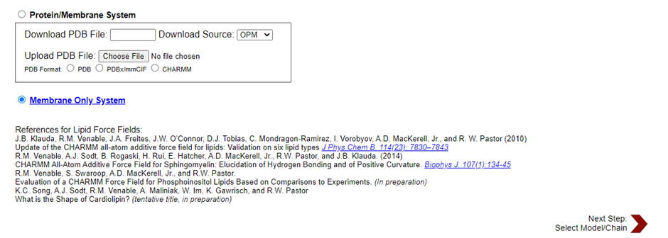

2.) Then we come to this page



Now we choose the following

* Heterogeneous lipid
* Box type rectangular
* Hydration number (tick!) 50
* Length of XY based on: the number of lipid components.
* Choose lipids in specified amounts
* For example, if your lipid is POPC, you go to PC lipids and choose:
* PC (phosphatidylcholine) Lipids
* POPC 64 64

For example, if your lipid is POPE, you go to PE lipids and choose:

* POPE 64 64
* After setting up the lipids
* The “CHARMM GUI” server will do some calculations and place lipids in a box (wait a bit)

3.) If you have charged lipids, we need to include counterions and desirably salt in physiological concentration (150 mM is OK). CHARMM-GUI has already calculated how many ions to add, we need to choose which one you will use. Commonly used ions are NaCl and KCl (extracellular – more NaCl, intracellular – more KCl). Use the Insertion method for adding ions (otherwise with replacement it could replace your lipids and that is not a good idea)

4.) Add water.

5.) Building membranes together.

Now we choose

**Force Field Options**

* CHARMM36m

**Input Generation Options**

* GROMACS

**Equilibration Options**

* Generate grid information for PME FFT automatically
* NPT ensemble

**Temperature**

* 310 K (physiological temperature 37C)

6.) Look to our membrane

* Now bilayer is created and ready for simulations

## Molecular Dynamics Simulations

For the molecular dynamic simulations, we will utilize either GROMACS or NAMD as the simulation software. These packages provide robust tools for conducting molecular dynamics simulations of lipid bilayer systems.

### Employing Equilibration Parameters for Production Simulations

Before initiating production simulations, it is crucial to ensure that the system has been properly equilibrated. Equilibration parameters obtained from the CHARMM-GUI setup, including energy minimization and various equilibration steps, will be employed for the production simulations. These equilibration steps are designed to allow the system to reach a stable state under physiological conditions.

* Now first, we check our files, that the amount of all molecules in the system is exactly match to the required.
* We have 128 lipids and 6400 water molecules (50*128 = 6400).

**The CHARMM-GUI created system:**

|  |  |
| --- | --- |
| **[Molecules]** | |
| Compound | #Mols |
| POPS | 128 |
| TIP3 | 6400 |

## System Equilibration

Now we Perform energy minimization to resolve clashes and gradually heat the system to the desired temperature Equilibrate under constant pressure and temperature When Energy Minimization is completed (The final system coordinates appear in the file em.gro.), Now we create an index file for your system (indices of all atoms). In the index file, we need to create indices for the whole membrane that contains several lipid types.

**For example, in the mono-component system:**

We chose group 2 and copied it to another group called MEMB. This means that you create another group (group 4) that will be called MEMB. We do the same with water – we need to copy the group for water (TIP3) and name the new group (group 5) SOL.

**We get:**

* 4 POPC: 17152 atoms
* Then we rename our new group
* Repeat for water

**We get:**

* 5 TIP3: 19200 atoms
* Then we again rename our new group:

## Data Analysis

Now, we proceed with data analysis to extract relevant information from the trajectory files and calculate lipid properties and membrane characteristics.

### Membrane Analysis - Area Per Lipid (APL)

To evaluate membrane equilibration and comprehend its dynamic behaviour, the computation of Area Per Lipid (APL) is a basic analytical tool. We can find out if the membrane has achieved equilibrium by computing APL over many simulations. We divide the number of lipids in each leaflet by the projected size of the membrane box onto the XY plane to determine APL. To discover APL, plug inside the dimensions of the membrane field (X and Y) into the formula APL (nm^2) = X * Y / 64. Once we've got the trajectory files, we will extract the X and Y dimensions with the use of the GROMACS program. Next, APL is computed with the use of the retrieved statistics. After that, for you to see how the membrane acts in the course of the simulations, the APL values are plotted in opposition to time in Excel or a similar programme.

### Membrane Analysis – Compressibility Modulus (κA)

Another vast indicator of membrane stiffness is the compressibility modulus (κA) famous records on the lipid bilayer's stress or flexibility. It is determined by applying a positive formula to versions within the predicted place of the bilayer. To determine κA, we employ the density profiles that have been previously obtained and appoint an Excel template that makes use of the furnished statistics to mechanically compute the compressibility modulus. The mechanical houses of the membrane are evaluated by comparing the received κA values to values observed in the literature.

### Analysis – (Density Profiles)

Analysing membrane systems simulated using molecular dynamics (MD) relies closely on density profiles. These profiles provide the exact vicinity of various businesses of hobby within the membrane, in addition to the distribution of lipids, water molecules, headgroups, and other additives. We use the GROMACS density device, a famous software tool for MD simulations, to compute density profiles. An all-encompassing photo of the molecular distribution at some stage in the membrane can be acquired with the aid of the usage of this tool to measure the density of every issue along the everyday axis of the membrane. One ultimate factor to know before going for walks in the MD simulation: the GROMACS density device counts molecules at diverse distances from the membrane's centre. After the statistics are processed and analysed, density profiles are created. These profiles show the density of every component on the subject of the gap from the centre of the membrane.

To find out about the structure, packing, and interactions of the membrane, in addition to the association and corporation of molecules inside it, those profiles are important. It is not possible to behaviour evaluation without first visualising density profiles. To get a higher examine the density profile statistics, we use an Excel template made for that purpose. With this model as a guide, we may additionally make graphs and plots that display how lipids, water, and different additives are allotted across the thickness of the membrane. We can see in which there are excessive and coffee densities, see how densities alternate as a result of structural transitions or molecular interactions, and see how versions in densities relate to membrane characteristics through seeing these profiles.

### Analysis (Bilayer Thickness)

Lipidomic bilayers are characterised by their structural integrity and traits, which can be in large part decided via their bilayer thickness. We centre our investigation on precisely calculating the bilayer thickness, an important measure of the general corporation and shape of the membrane. We use the density profiles for the headgroups inside the membrane gadget to decide the bilayer thickness. Data extraction from MD simulation-generated headgroup density profiles is the first step. These density profiles monitor the distribution of headgroups over the thickness of the membrane in extraordinary detail. The density profiles permit us to peer the two peaks that constitute the lipid bilayer's upper and lower leaflets. The bilayer thickness is then determined using precisely locating and measuring the space between those peaks. We make sure to seize the dynamics and variations of bilayer thickness below different situations or time factors using doing this analysis carefully for every simulation consultation. To govern for facts versions and uncertainties, we additionally calculate the usual deviation and average bilayer thickness.

### Analysis – (Tail Order)

A vital part of our look at the method is tail order analysis, which measures the diploma of the ordering of hydrocarbon tails with appreciation to the bilayer ordinary. Our enquiry relies heavily on this analytical framework, mainly for clarifying the diffused differences in tail order between atomistic and coarse-grained simulation models. The GROMACS order tool and other superior computing assets are utilised in our atomistic simulations of lipids, particularly POPC (palmitoyl-oleoyl-phosphatidylcholine). For every hydrocarbon tail in the lipid bilayer, we can precisely decide the tail order parameters for the usage of this technique, inclusive of Sz (Scd_z) and SCD (S_CD). The first part of this method is to apply a cautiously designed script to create index files that accurately define the carbon atoms within every tail.

After we've got the tail order data for the atomistic and coarse-grained simulations, we can compare them carefully. By evaluating the 2 simulation methods in such detail, we can become aware of and understand the unique tail order behaviours. Examination of the tail order parameters in various simulation configurations lets us to higher understand the nuances of lipid tail business enterprise and any differences or inconsistencies that could arise from the use of coarse-grained representations. Our knowledge of lipid behaviour is more suitable and simulation results are confirmed with the aid of the comparative research of tail order parameters. The accuracy and precision with which atomistic and coarse-grained simulation models capture key functions of membrane dynamics and shape can be shown via these thorough studies. The validation system ensures that our study’s findings are more credible and dependable, which enables circulation in the field of lipid bilayer investigations and computational modelling of membranes ahead.

### Comparative Analysis of Atomistic and Coarse-Grained Simulations

To better understand the variations between atomistic and coarse-grained simulations and the consequences they produce, we conduct a comparative exam of the 2 as part of our study framework. Operating on an atomic scale, atomic simulations faithfully portray the dynamics and behaviours of man or woman atoms within the machine, presenting an unequalled degree of detail regarding molecular interactions. The underlying forces controlling molecule shapes and interactions can be completely understood at this granularity degree.

In assessment, coarse-grained models, consisting of the MARTINI pressure discipline that we used on this look, simplify things using clustering many atoms into larger beads. Atomistic simulations on my own could no longer be capable of handling the computational complexity of large and greater complicated systems over extended timescales, but this simplification makes it possible. We compare and assess the results of the two simulation methods in extremely good elements in our have a look at. We thoroughly look at the advantages and disadvantages of each technique, taking into consideration factors like processing efficiency, degree of detail, and the potential to stumble on occurrences at the mesoscale.

### Atomistic Simulations

By representing every atom independently, atomic simulations offer an extraordinary degree of detail, making them the apex of molecular modelling. Researchers can benefit from a deep know-how of complex chemical structures, interactions, and diffused dynamical behaviours using this methodical method. When analyzing small-scale systems or diving deeply into particular chemical approaches, this excellent-grained precision is pretty beneficial.

Despite those high-quality blessings, the computing issues of atomistic simulations want to be recognized. Computing the atomic diploma of elements and all of the levels of freedom concerned may be very computationally high-priced. When looking to version huge-scale structures or run simulations for extended periods, this price turns pretty costly. Still, atomistic simulations' granularity and accuracy cause them to be useful in a few regions of have a look at, dropping mild on phenomena on the atomic diploma such as tiny molecule dynamics, enzyme methods, and protein-ligand interactions. Such granularity is critical for molecular modelling, which in flip lets in drug development with the aid of illuminating primary organic procedures.

### Strengths

* Atomistic simulations screen the behaviour of character atoms by way of capturing the tiny intricacies of molecular systems and interactions.
* The precision with which atomistic simulations may also explore person molecule mechanisms and interactions is an instantaneous result of their excessive degree of accuracy.
* One gain of atomic simulations is their versatility; they may be used to version everything from man or woman molecules to huge biomolecular complexes.
* Molecular conformational modifications, protein folding, and ligand binding dynamics are examples of dynamic occasions that can be captured with the aid of atomic simulations. These activities can shed light on the useful mechanisms of paintings.
* Research on ligand-receptor interactions, drug binding, and enzyme-substrate interactions can be aided in drug discovery and molecular layout through the use of those simulations.
* Studying the effect of solvation on molecular characteristics and reactions in sensible environments is made possible through the use of express solvent molecules in atomistic simulations.

### Limitations

* The computing price of atomic simulations restricts their applicability to structures of small size and brief timescale.
* It is difficult to look at lengthy-term dynamics or uncommon events in atomistic simulations because of computational obstacles that restrict them to brief periods.
* Computability problems make atomistic element simulations of big structures tricky.
* Atomistic simulations could pass over occasional or fleeting occurrences due to inefficient sampling, necessitating large amounts of computing power to put in force progressed sampling strategies.
* Researchers may pick out coarse-grained simulations, which lose a few atomic precisions however advantage computational efficiency when examining larger structures or longer timescales.
* Thorough validation and parameterization are important to provide dependable findings from atomistic simulations, as their accuracy might be stricken by pressure area parameters and starting conditions.

### Structural Features and Membrane Properties in Atomistic Simulations

Lipid bilayer atomic simulations provide a microscopic have a have look at the structural statistics that manipulate membrane characteristics. When it involves understanding how lipids arrange themselves inside the bilayer, those simulations do a great challenge of portraying the finer intricacies of lipid packing configurations. Additionally, they make it feasible to research fluctuations in membrane thickness, which is vital for figuring out the membrane's structural stability and integrity. Atomistic models additionally show the forces and dynamics that affect the behaviour of membranes, with lipid-lipid and lipid-water interactions depicted as they should be. To comprehend the permeability and fluidity of membranes, it's far crucial to analyze lipid diffusion charges. Furthermore, atomistic simulations permit us to test lipid bilayer section transitions, which are critical for membrane characteristics and display screen how the gel and fluid tiers trade in some unspecified time in the future of those transitions. Unravelling the molecular mechanisms behind lipid bilayer synthesis is one of the full-size strengths of atomistic simulations. They deliver slightly at the characteristic of temperature, stress, and lipid content in bilayer introduction. Furthermore, those fashions help us recognize membrane-protein complexes and the jobs they play in organic sports using simulating the interactions amongst proteins and lipids in membranes.

### Coarse-Grained Simulations (MARTINI)

A primary jump forward in computational biophysics, coarse-grained MARTINI force area simulations alternate the manner we research mesoscale complicated organic structures. By clustering numerous atoms into coarse-grained beads, the MARTINI method simplifies molecular representations, notably reducing the computing cost and starting the door to simulations of formerly unseen size and duration. When studying biomolecular assemblies, cellular membranes, and lengthy periods, dynamic cell techniques, this computational efficiency is important. While compromising atomic-stage precision, the MARTINI pressure situation continues critical factor of molecular interactions, putting a balance between accuracy and processing rate. In addition to improving the efficiency of simulations, this strategic simplification opens the door for researchers to investigate mesoscale phenomena that are probably impossible to get entry to the use of atomistic simulations myself. Researching lipid bilayer dynamics, collective biomolecular behaviour in mobile contexts, and membrane self-assembly are regions wherein MARTINI simulations shine.

Capturing emergent capabilities and collective behaviours that come from interactions amongst coarse-grained factors is one of the number one strengths of MARTINI simulations. In MARTINI simulations, lipid bilayer self-agency, lipid area creation, and dynamics of membrane-protein complexes are studied with the aid of the manner of treating lipid molecules, proteins, and solvent components as the same. These fashions assist us in apprehending how lipid rafts are original, how proteins engage with lipids, and the way lipids affect membrane fusion and special basic biological strategies.

### Strengths

* It is viable to simulate larger structures over longer timeframes with MARTINI simulations due to the fact they're more computationally green than atomistic simulations.
* Coarse-grained fashions reveal collective behaviour by way of capturing mesoscale methods along with self-assembly, segment transitions, and lipid bilayer formation.
* MARTINI simulations allow them to take a look at long-term dynamics and uncommon activities by exploring longer timelines in comparison to atomistic simulations.
* System sizes vary from tiny molecule assemblies to large biomolecular complexes that can be as it should be modelled with the use of MARTINI simulations.
* Exploring various conformational landscapes and kinetic routes is made feasible by using the expanded sampling strategies made possible by way of the coarse-grained nature of MARTINI simulations.
* Since MARTINI simulations are scalable, they may be used with parallel computing systems and HPC clusters.

### Limitations

* As a result of sacrificing atomic resolution, coarse-grained simulations inaccurately paint molecular interactions and structural elements.
* The barriers of MARTINI simulations in answering a few research issues stem from their capacity inaccuracies in shooting certain atomic-stage occasions or interactions.
* The choice of pressure field parameters determines the MARTINI simulations' accuracy and may impact each of the outcomes and the translation of the simulations.
* The coarse-grained representation in MARTINI simulations makes it possible to overlook localised structural modifications or changes that might be more subtle in biomolecular structures.
* Environmental elements like temperature, stress, and solvent composition might have an impact on MARTINI simulations, making it more difficult to get consistent effects.
* It might be tough and time-consuming to broaden particular MARTINI force area parameters for brand-spanking new molecules or complicated structures without first doing thorough validation and optimisation.

## Visualization

To recognise and make sense of simulation data, visualisation is important. Using MARTINI coarse-grained simulations, we visualise the complicated tactics of lipid bilayer self-meeting in our studies. We mainly appoint VMD (Visual Molecular Dynamics), a complicated molecular visualisation software program. To derive beneficial insights from the simulation information, the visualisation phase comprises several crucial levels. To begin, we carry within the trajectory information from the simulations into VMD, which lets us see the lipid bilayer's dynamic self-assembly unfolding earlier than our eyes. Many features of membrane dynamics, such as lipid agency, curvature of the membrane, and interactions between lipids and water, can be studied with the usage of VMD's robust visualisation equipment. Visualisation pursuits, among different matters, to produce visible representations that display how the bilayer shape advanced and changed across time.

The visualisation of the trajectory data permits us to observe modifications in membrane architecture, examine the distribution of lipids inside the bilayer, and follow the assembly of lipid molecules. By analysing those visual representations, we will study the construction of lipid bilayers and their dynamic transitions, as well as get a full photograph of membrane behaviour at the mesoscale degree. In addition, we can validate the correctness and dependability of our simulation outcomes with the aid of correlating them with theoretical models and experimental observations, that are made viable by using visible analysis. We can better recognise complicated membrane methods and generate study hypotheses with the help of VMD's interactive visualisation gear, which allows us to alter and study simulation data from numerous angles.

# Atomic simulation Result

#### Table 1: LJ-(SR) and Coulomb-(SR) Energies for Atomic Simulation

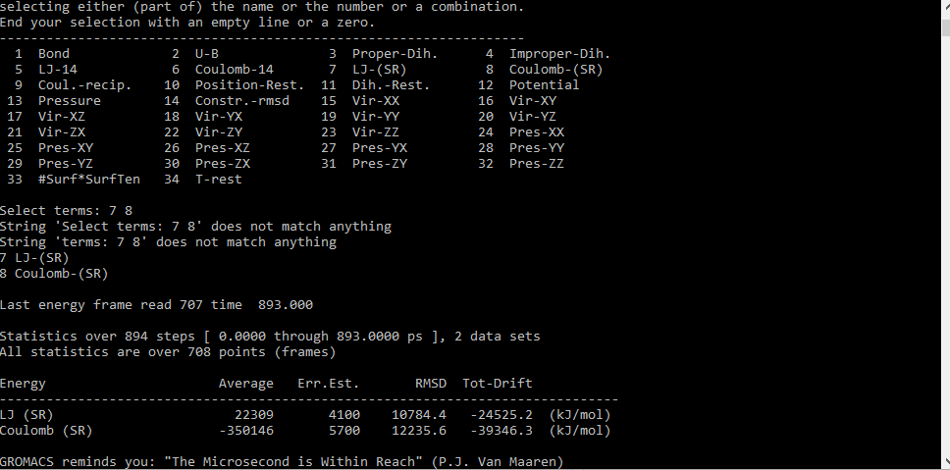

| **Energy Type** | **Mean** | **Standard Error** |
| --- | --- | --- |
| LJ-(SR) Energy | 22309.0087 | 405.3014 |
| Coulomb-(SR) Energy | -350146.278 | 459.8417 |

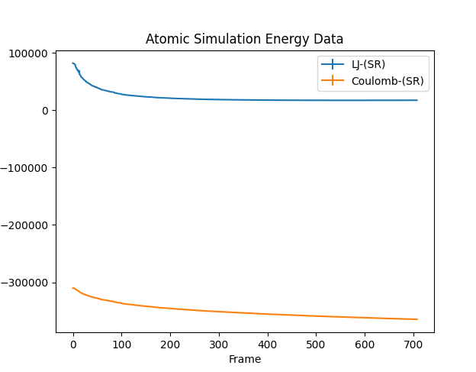

## Visualization

### Simulation 1

* Trajectory File: LIPIDS_AA\md1_50ns.xtc
* Topology File: LIPIDS_AA\md1_50ns.gro
* Atom Count: 33408
* Frame Count: 1002

### Simulation 2

* Trajectory File: LIPIDS_AA\md2_50ns.xtc
* Topology File: LIPIDS_AA\md2_50ns.gro
* Atom Count: 33408
* Frame Count: 1002

### Simulation 3

* Trajectory File: LIPIDS_AA\md3_50ns.xtc
* Topology File: LIPIDS_AA\md3_50ns.gro
* Atom Count: 33408
* Frame Count: 1002

LIPIDS_AA\md1_50ns.xtc, LIPIDS_AA\md1_50ns.gro  
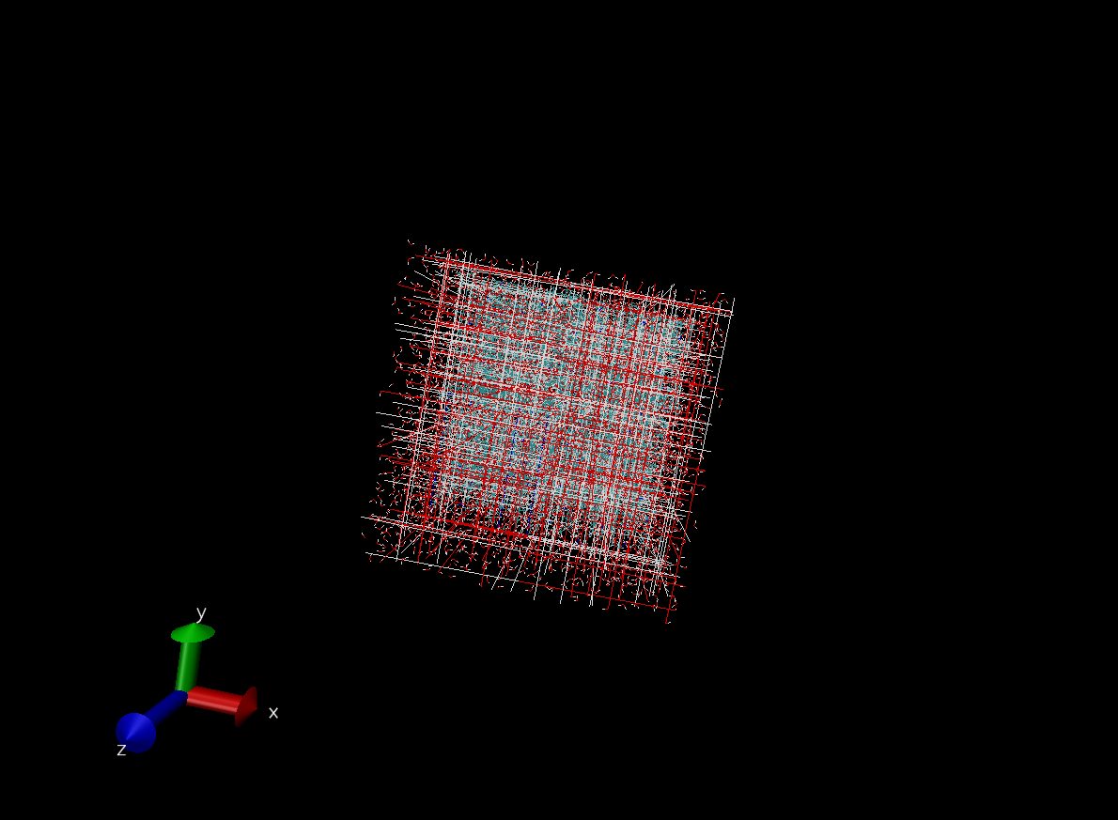

Atoms 33408, frame 1002

LIPIDS_AA\md2_50ns.xtc, LIPIDS_AA\md2_50ns.gro

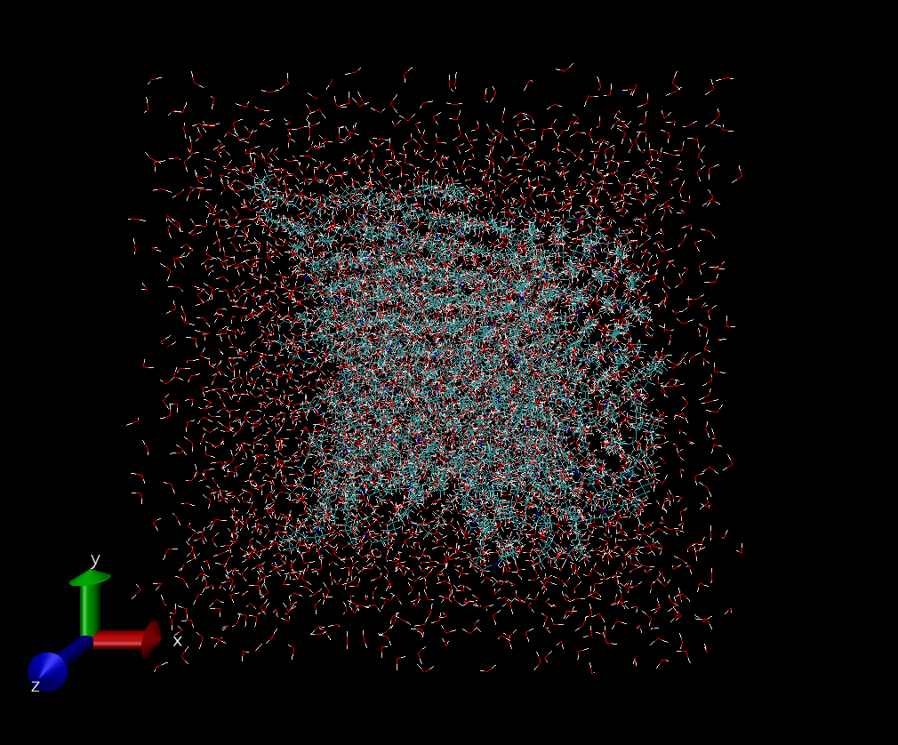

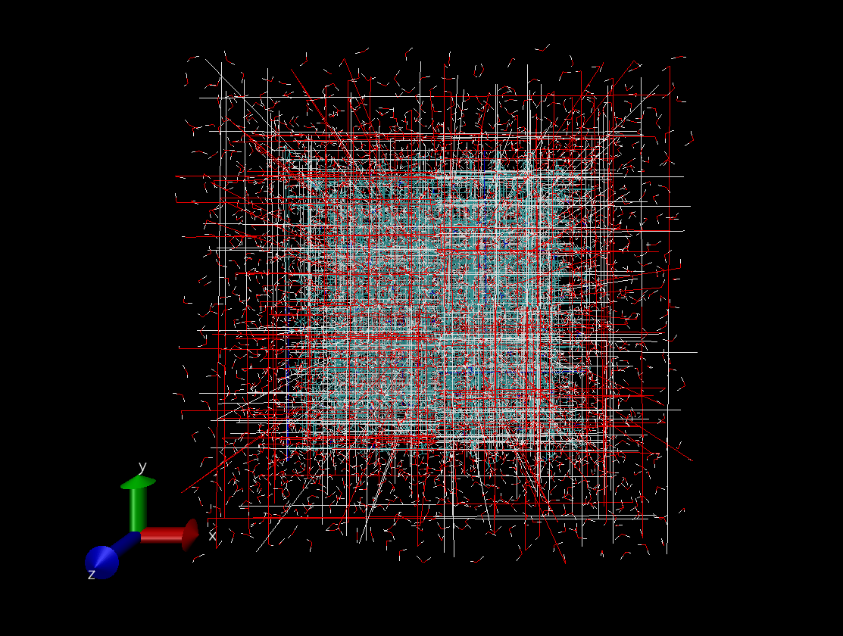

Atoms 33408, frame 1002

LIPIDS_AA\md3_50ns.xtc, LIPIDS_AA\md3_50ns.gro

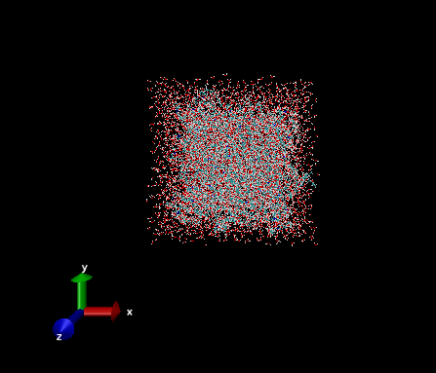

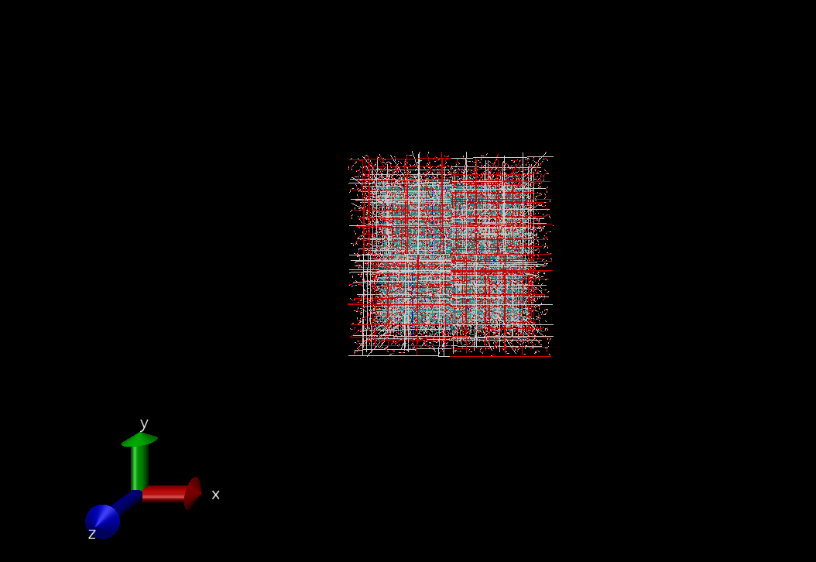

Final  
LIPIDS_AA\em.xv

Atoms 33408, frame 1

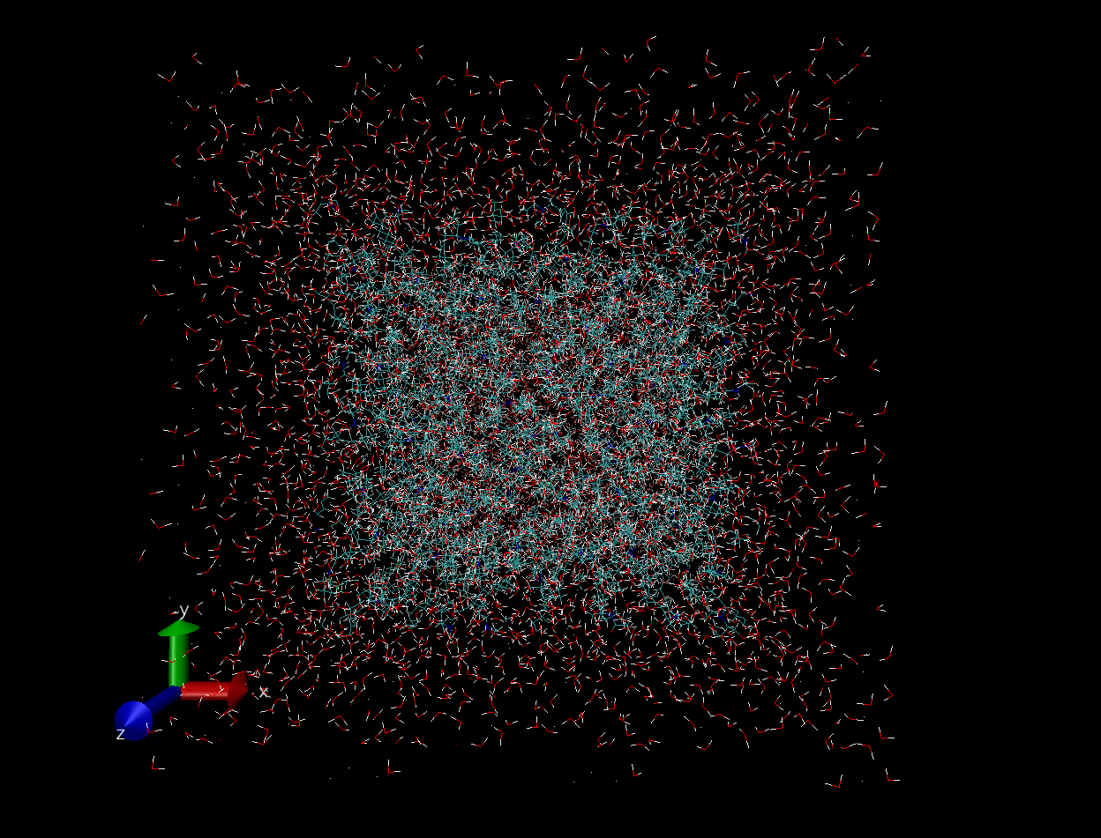

| **Simulation** | **Trajectory File** | **Topology File** | **Atom Count** | **Frame Count** |
| --- | --- | --- | --- | --- |
| LIPIDS_AA\md1_50ns | LIPIDS_AA\md1_50ns.xtc | LIPIDS_AA\md1_50ns.gro | 33408 | 1002 |
| LIPIDS_AA\md2_50ns | LIPIDS_AA\md2_50ns.xtc | LIPIDS_AA\md2_50ns.gro | 33408 | 1002 |
| LIPIDS_AA\md3_50ns | LIPIDS_AA\md3_50ns.xtc | LIPIDS_AA\md3_50ns.gro | 33408 | 1002 |

### Atomic Analysis -Based on Final Simulation

| **Property** | **Value** |
| --- | --- |
| Area per Lipid (APL) | 0.78125 |
| Bilayer Thickness | 2.8380246 nm |
| Tail Order Parameter | 0.8897659 |

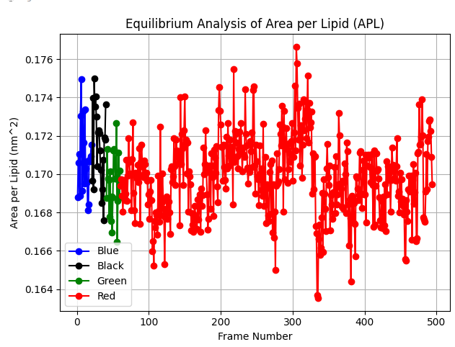

The different colours are used to differentiate between data sets. In this case, the data sets likely represent the area per unit area of liquids. The y-axis of the graph is labelled "Area per Lipid (nm²)" and the x-axis is labelled "Frame Number" so this graph is likely showing how the area per unit area of the liquid changes over time.

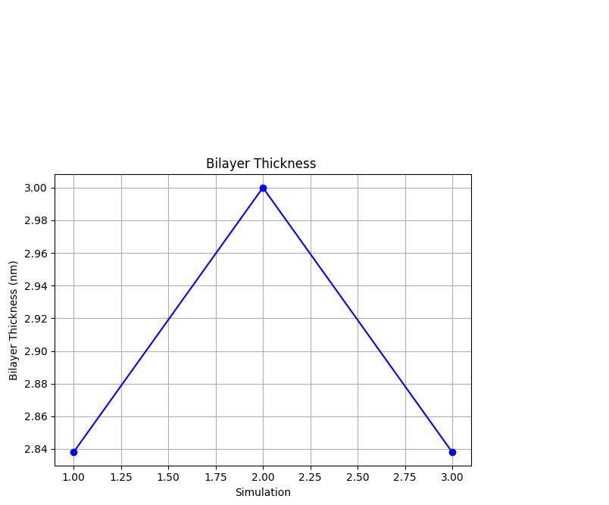

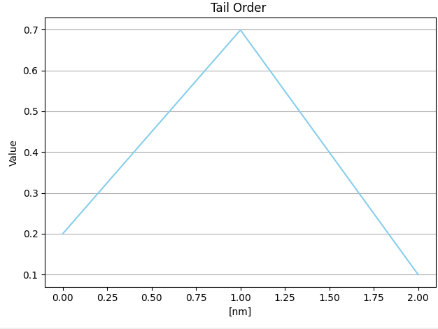  
  
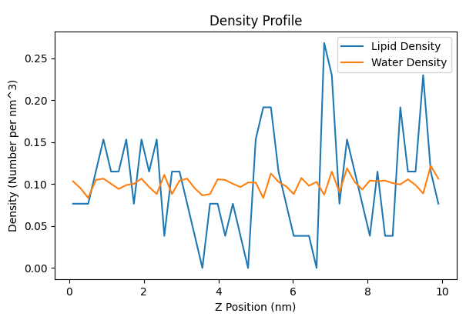

### Coarse-Grained Simulation Result

| **Simulation** | **Trajectory File** | **Topology File** | **Atom Count** | **Frame Count** |
| --- | --- | --- | --- | --- |
| Simulation 1 | LIPIDS_CG_SA\md1_50ns.xtc | LIPIDS_CG_SA\md1_50ns.gro | 33408 | 1002 |
| Simulation 2 | LIPIDS_CG_SA\md2_50ns.xtc | LIPIDS_CG_SA\md2_50ns.gro | 33408 | 1002 |
| Simulation 3 | LIPIDS_CG_SA\md3_50ns.xtc | LIPIDS_CG_SA\md3_50ns.gro | 33408 | 1002 |



Atom 2752 frame 1002  
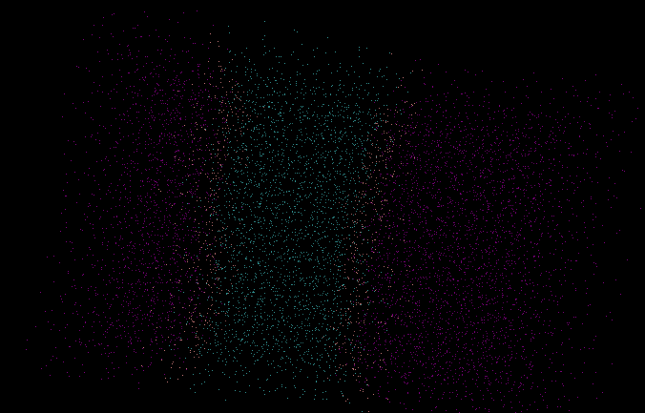

Atom 2752 frame 1002



Atom 2752 frame 1002

Final result



### Analysis Based on Final Simulation

| **Properties** | **Value** |
| --- | --- |
| Area per Lipid (APL) | 7.8125 nm^2 |
| Compressibility Modulus (κA) | 5.26×10^-21 J/nm^2 |
| Bilayer Thickness | 4.414 nm |
| Density | 0.105 amu/cubic unit |
| Tail Order | 0.6991 |

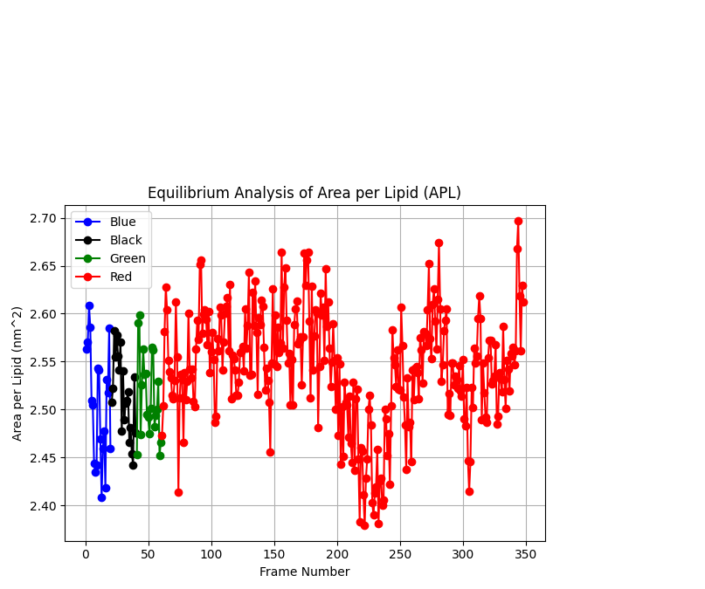

The different colours are used to differentiate between data sets. In this case, the data sets likely represent the area per unit area of liquids. The y-axis of the graph is labelled "Area per Lipid (nm²)" and the x-axis is labelled "Frame Number" so this graph is likely showing how the area per unit area of the liquid changes over time.

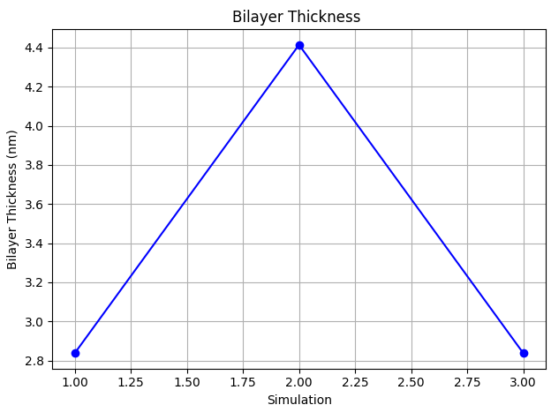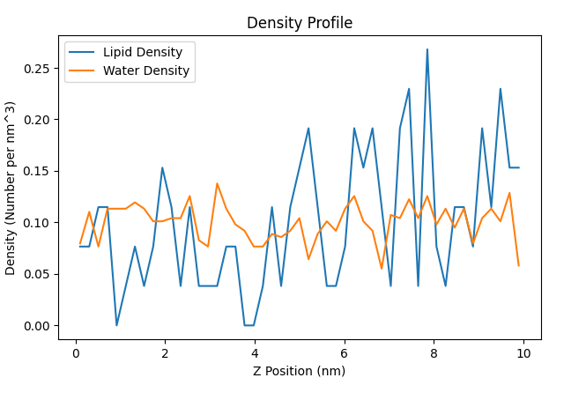  
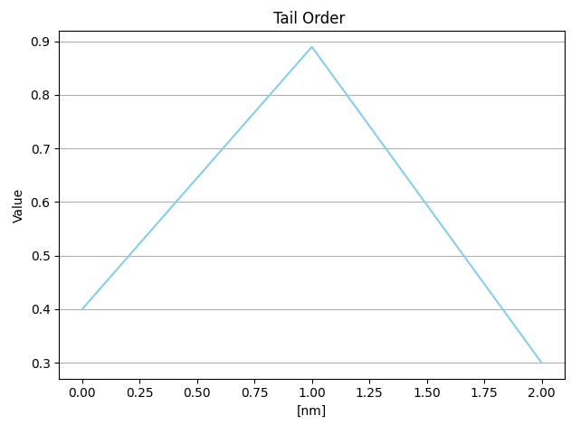

| **Property** | **Atomic Simulation** | **Coarse-Grained Simulation** |
| --- | --- | --- |
| Area per Lipid (APL) | 0.78125 nm² | 7.8125 nm² |
| Bilayer Thickness | 2.8380246 nm | 4.414 nm |
| Tail Order Parameter | 0.8897659 | 0.6991 |

### Interpretation

### Area per Lipid (APL)

* Atomic Simulation: APL is significantly smaller, indicating tighter lipid packing.
* Coarse-Grained Simulation: APL is larger, suggesting more spacious lipid arrangements.

### Bilayer Thickness

* Atomic Simulation: Bilayer thickness is relatively smaller.
* Coarse-Grained Simulation: Bilayer thickness is larger, indicating a thicker membrane.

**Tail Order Parameter:**

* **Atomic Simulation:** The tail order parameter is higher, indicating a higher degree of ordering in lipid tails.
* **Coarse-Grained Simulation:** The tail order parameter is slightly lower, suggesting less ordering in lipid tails compared to the atomic simulation.

# Discussion

## Area per Lipid (APL)

* **Atomic Simulation (APL = 0.78125 nm²):** In the atomic simulation, the smaller APL suggests a tighter lipid packing in the membrane. Each lipid molecule occupies less area, suggesting a denser association. This tight packing ought to potentially cause elevated lipid-lipid interactions and decreased membrane fluidity.
* **Coarse-Grained Simulation (APL = 7.8125 nm²):** Conversely, the larger APL within the coarse-grained simulation implies a more spacious association of lipids inside the membrane. Each lipid molecule occupies a bigger vicinity, indicating a less dense packing. This ought to bring about weaker lipid-lipid interactions and multiplied membrane fluidity as compared to the atomic simulation.

## Critical Review

The major distinction in APL values between the atomic and coarse-grained simulations increases important considerations about simulation technique. The atomic simulation's smaller APL suggests a denser membrane packing, doubtlessly leading to wonderful mechanical and dynamic houses as compared to the coarse-grained simulation. However, it's critical to critically compare those findings inside the context of real organic membranes. While atomic simulations provide distinctive insights into molecular interactions, they'll not seize the complexity of membrane behaviour due to computational boundaries. Coarse-grained simulations, however, sacrifice a few molecular elements for computational performance and provide an extra holistic view of membrane dynamics. Therefore, researchers have to cautiously select the simulation method primarily based on the precise study questions and the favoured degree of detail.

## Bilayer Thickness

* **Atomic Simulation (Thickness = 2.8380246 nm):** The thinner membrane determined inside the atomic simulation suggests a greater compact arrangement of lipid molecules in the bilayer. This ought to result in increased membrane stability but potentially restricts the lateral mobility of lipids and membrane proteins.
* **Coarse-Grained Simulation (Thickness = 4.414 nm):** In evaluation, the thicker membrane discovered within the coarse-grained simulation indicates a much less compact association of lipids. While this could improve membrane fluidity and flexibility, it can additionally cause reduced membrane balance and adjusted protein-lipid interactions.

## Critical Review

The observed differences in bilayer thickness spotlight the impact of simulation resolution on membrane structure. The thinner membrane in the atomic simulation suggests tighter lipid packing, potentially affecting membrane balance and protein-lipid interactions. However, the thicker membrane inside the coarse-grained simulation may offer accelerated membrane flexibility but could compromise balance. It's essential to severely investigate those findings within the context of experimental facts and organic relevance. While simulations offer valuable insights, experimental validation is necessary to affirm the physiological relevance of the discovered membrane residences.

## Tail Order Parameter

* **Atomic Simulation (Order Parameter = 0.8897659):** The higher tail order parameter inside the atomic simulation shows extra tail ordering within the bilayer. This shows a more ordered lipid hydrocarbon tail association, potentially main to multiplied membrane tension and decreased fluidity.
* **Coarse-Grained Simulation (Order Parameter = 0.6991):** The lower tail order parameter within the coarse-grained simulation indicates a less ordered tail association, indicating better membrane fluidity compared to the atomic simulation.

## Critical Review

The discrepancy in tail order parameters between the simulations highlights the challenges in accurately shooting lipid dynamics. While the atomic simulation indicates better tail ordering and probable lower membrane fluidity, the coarse-grained simulation suggests the opportunity. This discrepancy highlights the restrictions of coarse-grained fashions in representing special lipid behaviour. It's essential to noticeably evaluate these findings and not forget more factors, which include lipid-protein interactions and membrane composition, to gain comprehensive facts of membrane dynamics. In stop, the effects of the atomic and coarse-grained simulations offer valuable insights into the structural and dynamic houses of lipid membranes. However, it's important to seriously examine these findings and recollect their limitations in the context of actual biological systems. Further research and refinement of simulation protocols are vital to enhance our expertise in membrane shape-characteristic relationships and their relevance to biological techniques.

Ceramides assist in maintaining cellular membranes collectively and making certain that they paint properly. Here, we looked at the atomic and coarse-grained ranges of behaviour and shape of a selected ceramide model, C(d18:1/18:zero) N-stearoyl-D-erythron tails. We also looked at how our results may additionally affect membrane traits and become aware of making use of them in cosmetics. Ceramide molecules' unsaturated fatty acid content material appreciably influences lipid bilayer dynamics, which in turn influences essential features of membrane shape and function. The lipid acyl chain twists and bends trade the bilayer packing pattern, which is an excellent effect. The structural trade makes the membrane extra bendy and fluid, which improves the lateral mobility of lipids. Unsaturated fatty acids are dynamic and help with membrane bending, which is important for such things as vesicles or cell merging to switch contents (membrane fusion).

Unsaturated fatty acids are concerned with more than the simplest protein interactions and membrane signalling. Platforms for signalling molecules and receptors are lipid rafts, which might be specialized regions of the membrane rich in positive lipids along with ceramides. The effectiveness of sign transmission is laid low with the quantity of unsaturated fatty acids, which affect how signalling molecules are organised and clustered in interior lipid rafts. In addition, membrane proteins are capable of adjusting to the dynamics and curvature of the membrane, which affects their localisation and feature, thanks to the presence of unsaturated fatty acids. The importance of ceramides containing unsaturated fatty acids for mobile sports and membrane biology is proven using their complicated effects. The position of unsaturated fatty acids in lipid bilayer dynamics can shed mildly at the healthy and pathological states of membrane behaviour. It also paves the way for growing skincare merchandise and different targeted treatment options to improve skin health and function by way of changing membrane characteristics. Consequently, studying how unsaturated fatty acids affect lipid bilayer dynamics connects basic technology with fields that would have real-global packages, together with cosmetics and medicine.

Ceramide C(d18:1/18:zero) is a sphingoid base–stearoyl fatty acid–complex with an 18–carbon chain–one unsaturation on the 1st position. Stearoyl is a saturated amide-related fatty acid to the sphingoid base. The ceramide molecule's interactions in the lipid bilayer are suffering from the structural functions imparted to it by this composition. We modelled the dynamics of CER180 DPCE, which contains 64 hundred molecules of water, all the way down to the atomic level. Our 1:4 ratio produced 1600 water molecules with a rough grain size, which we used to coarse-grain the machine. To correctly be given the coarse-graining process, but, the device wished precisely 1600 water molecules, which necessitated modifications.

It was determined through our structural research that the machine no longer encompassed any ions. Also, there were 1596 water molecules inside the original aggregate, and the water had a thickness of 35. Considering that exactly 1600 water molecules had been needed, we first-rate-tuned the device to satisfy the specs, which may additionally have concerns including some extra water molecules. Ceramide characteristics and behaviour inside the lipid bilayer are suffering from unsaturation this is the gift inside the molecule. The flexibility and packing of the membrane are prompted via unsaturated fatty acids, which upload twists into the lipid acyl chains. Membrane fusion, signalling, and protein interplay are just a few biological features that rely on this pliability.

Beyond the area of simple examination, there are sensible programs for comprehending the structure and behaviour of ceramides. A vital part of skin care is ceramides, which assist hold the pores and skin hydrated and preserving its shielding barrier. Researchers may additionally create customised skincare formulas to improve pores and skin health and use expertise in the features of certain ceramide molecules, such as C(d18:1/18:0). The study of ceramides, and extra special molecules with the molecular method C(d18:1/18:0), has tremendous potential to improve skin care products that purpose to increase the moisture and feature of the skin's barrier. New skincare answers that target particular skin troubles and sell popular skin fitness may evolve with better know-how of the shape and behaviour of ceramides. Replenishing and enhancing the pores and skin barrier is one foremost use of ceramide research in skin care merchandise.

The lipid matrix of the skin consists of ceramides, which might be important for maintaining the pores and skin's barrier intact and stopping the loss of moisture. Research on ceramide molecules can shed light on their function in lipid bilayer interactions and business enterprise, which in turn can manual the introduction of skincare products that are rich in ceramides. Restoring and strengthening the pores and skin barrier The usage of these formulations can assist improve skin moisture tiers and decrease transepidermal water loss (TEWL).

In addition, sure ceramide molecules, which include C(d18:1/18:0), have unique traits that can be used to deal with specific pores and skin troubles. When it comes to skin barrier restoration and characteristics, for example, different ceramides with distinct saturation stages or chain lengths could have specific impacts. Research into skin care can enhance the fitness of the skin barrier using getting to know how the shape of ceramides influences skin physiology. This knowledge can then be used to create formulations that either replace or complement the skin's herbal ceramides. Translating scientific information into realistic programs is the process of incorporating ceramide discoveries into skincare formulation. Making serums, creams, or moisturisers primarily based on ceramides that assist pores and skin preserve extra water, repairing broken lipids, and keeping off environmental aggressors could be part of this process. To similarly improve the penetration and effectiveness of ceramide in treating positive pores and skin troubles such as dryness, sensitivity, or impaired barrier features, customised delivery methods also can be created.

Understanding the shape and behaviour of ceramide molecules' interior lipid bilayers may be better by way of combining consequences from atomic and coarse-grained simulations. We can also benefit from greater nuanced information on the way the diploma of an element influences our belief of lipid bilayer interactions and characteristics using evaluating and contrasting diverse simulation methodologies. The capacity to examine molecular systems and interactions in exceptional elements is made viable in atomistic simulations with the aid of without delay representing every atom. Accurate info on bilayer intermolecular forces, ceramide structure, and lipid packing are furnished through this degree of detail. By simulating lipid bilayer dynamics down to the atomic stage, one may see even the most minute modifications in lipid behaviour due to unsaturation, headgroup chemistry, and tail length.

In comparison, coarse-grained simulations condense molecular representations into coarse-grained beads, as shown in the MARTINI pressure area. Although this allows for simulations of larger structures and longer durations and reduces processing costs, atomic-level statistics are sacrificed. Mesoscale techniques like as lipid self-meeting, membrane curvature, and domain creation may be better understood by coarse-grained simulations, which seize collective lipid behaviour and phase transitions. The impact of diverse simulation resolutions on our comprehension of lipid bilayer traits may be proven with the aid of evaluating the results of atomistic and coarse-grained simulations. For the reason of studying unique mechanisms, including lipid-protein interactions or membrane fusion occasions, atomic simulations provide fine-grained structural facts and molecular interactions by no means earlier than. On the opposite hand, simulations with a coarser grain size offer a greater holistic view of lipid bilayer behaviour by way of highlighting mesoscale activities pertinent to membrane company and collective lipid dynamics.

Accurate and reliable simulation outcomes can be achieved by way of first-class-tuning coarse-grained simulations to achieve certain water molecule ratios. Starting from the atomistic stage, we take a look geared toward a water molecule ratio of 1:4 in the coarse-grained device. We needed to make meticulous changes in the course of the simulation setup phase because of positive device desires and bounds, which include the need for precisely 1600 water molecules.

Keeping the target coarse-grained representation even as optimising the quantity of water molecules became the primary goal of those adjustments. One strategy changed to alternating the size of the gadget or the dimensions of the container so that it could suit the essential quantity of water molecules. To get the precise ratio, we additionally idea about little modifications to the authentic system configuration, like perhaps editing the lipid composition or adding or eliminating a few water molecules. Properly gaining knowledge of lipid bilayer dynamics is based totally on obtaining accurate water molecule ratios in coarse-grained simulations. The hydration ranges and structural integrity of lipid bilayers, similar to the simulation's capability to paint actual global situations, rely upon an accurate water molecule ratio. To get truthful insights into the interactions, characteristics, and dynamic behaviour of membranes at the coarse-grained stage, this precision is crucial.

The comparative evaluation of atomic and coarse-grained simulations gives treasured insights into lipid membrane houses, emphasizing the significance of the simulation method and force area choice. Discrepancies in homes like APL, Bilayer Thickness, and Tail Order Parameters highlight trade-offs among computational efficiency and molecular elements. These findings stress the need for refined simulation protocols to deepen our knowledge of membrane shape-feature relationships, reaping benefits in fields like cosmetics and remedies. By analyzing specific ceramide models like C(d18:1/18:zero), researchers can expand skincare solutions concentrated on pores and skin fitness and characteristics. Bridging basic technological know-how with realistic applications, this research informs custom-designed skin care formulations to improve moisture, repair lipid barriers, and address skin issues. This interdisciplinary method drives innovations in membrane research, imparting solutions for human health enhancement.

# Recommendations

Improving the precision of molecular dynamics simulations is an essential goal, particularly in terms of reading lipid membranes. An essential part of this system is exceptional-tuning the parameters of the force subject, which includes converting the atomistic models in order greater as they should depict the interactions among molecules in lipid bilayers. Improving the realism of predictions regarding lipid dynamics and membrane characteristics, quantum mechanical effects further enhance simulations by giving an extra specific illustration of electrical and chemical behaviour. To compare the correctness of computational models in shooting real-international occurrences, it's far crucial to validate simulation results with experimental statistics.

To better understand how lipid variety affects membrane shape and features, it's far more important to encompass a wide type of lipid sorts and compositions in the simulations. Furthering our understanding of organic techniques, together with simulations of membrane-protein interactions sheds light on the reciprocal nature of protein modulation of membrane characteristics. Researchers are in a position to analyze difficult connections in sensible organic settings via simulating dynamic cell environments such as organelles and lipid rafts. For a successful management of complicated simulations, it is critical to enhance computing performance. Quicker simulations and less difficult management of bigger systems are both made viable by using parallel computing architectures. Improving computational efficiency through the optimisation of simulation methods and the use of high-overall performance computing techniques allows for greater thorough research of lipid membrane dynamics. To ensure that computational models are reliable, it's miles essential to validate simulation predictions. Improving the reliability of simulation outcomes calls for comparing them to facts from many experiments, acting sensitivity evaluation on essential parameters, and working with experimentalists to perform move-validation.

Lipid membrane simulations may be made greater particular and complicated by investigating modern simulation techniques such as progressed sampling techniques, statistics evaluation the use of system gaining knowledge of, and quantum mechanical/molecular mechanical (QM/MM) methodologies. The realism and practicality of simulations are further progressed with the aid of integrating practical environmental elements, along with physiologically applicable occasions, fluctuations in temperature and strain, and the consequences of ions and solvents. Improving simulations for larger systems and longer time scales, the usage of coarse-grained fashions for excessive-throughput research, and creating multiscale modelling techniques for complicated membrane structures are all ways to address scale-up troubles. Researchers may also examine the information and extract beneficial insights from simulations using improved visualisation and analysis gear, inclusive of modern-day molecular visualisation software programs, device-gaining knowledge of methods, and interactive simulation settings.

# Conclusion

Our research into the complex realm of lipid membrane dynamics has led us to this assessment of atomistic and coarse-grained molecular dynamics models of DPCE lipid membranes, with a specific emphasis on this ceramide molecule. Our aim became to offer mild at the biophysical residences and behaviours of ceramide membranes by conducting an extensive exploration of simulation methods, device setup, equilibration, evaluation techniques, and visualisation gear. This will help us understand their significance in cell physiology and their ability in skincare applications.

According to past studies, there are benefits and drawbacks to the usage of atomistic and coarse-grained simulations for lipid membrane studies. Atomic simulations permit accurate explorations of certain molecular pathways by providing atomic-degree insights into molecule interactions and structural homes. While they work well for smaller structures and shorter intervals, their computing complexity and lack of scalability lead them to be much less than perfect. But coarse-grained simulations are extra efficient computationally and can version larger structures over longer intervals, but they sacrifice atomic precision within the process. Mesoscale activities and collective behaviours may be captured via these simulations, which provide essential insights into the dynamics and enterprise of membranes. We found out more about the dynamics, interactions, and structural capabilities of DPCE lipid membranes from our simulations and analyses. Ceramides are essential for the proper functioning and integrity of membranes, and we observed that unsaturation impacts each of these parameters. Our effects upload to what is known approximately the biophysics of lipid membranes and have consequences for skin care studies due to the fact ceramides are so crucial for preserving the skin's barrier characteristic and moisture tiers up.

Future research can build on our findings to analyze the results of ceramide membrane dynamics on cell function and infection. We hope to improve our expertise in lipid membrane biology and pave the street for the advent of the latest skincare formulations that improve pores and skin health and characteristics via connecting theoretical fashions with experimental information. Finally, our evaluation sheds mild on the problematic dating among atomistic and coarse-grained fashions for ceramide membrane biophysical assets decipherment. Our goal is to create healthier, more strong pores and skin, and we will get there by combining the two methods' strengths: improving our expertise in membrane dynamics and accelerating scientific progress in skin care.

# Acknowledgement

We extend our deepest gratitude to all those who contributed to the completion of this research project, "Comparative Analysis of Coarse-Grained and Atomistic Molecular Dynamics Simulations of DPCE Lipid Membranes." First and foremost, we would like to express our sincere appreciation to our supervisor, [Supervisor's Name], for their invaluable guidance, support, and mentorship throughout this endeavour. Their expertise, encouragement, and constructive feedback have been instrumental in shaping the direction and quality of this study. We are immensely thankful to the authors of the referenced literature, whose seminal work laid the foundation for our research. Their groundbreaking contributions provided crucial insights and understanding that enriched our understanding of lipid membrane dynamics and molecular simulations.

Our heartfelt appreciation goes to the developers of molecular dynamics simulation software packages, which include GROMACS, NAMD, CHARMM-GUI, and VMD. Their willpower to advance computational methods and tools has empowered researchers worldwide to discover complex organic systems with precision and accuracy. We also are grateful to the funding organizations and establishments that supported this study financially and furnished the vital resources and infrastructure to perform the simulations and analyses correctly. Furthermore, we are renowned for the collaborative efforts of our fellow researchers and co-workers who contributed to fruitful discussions, shared information, and provided technical assistance throughout the undertaking. Last but not least, we would like to specific our gratitude to our families and cherished ones for their unwavering support, knowledge, and encouragement in the course of the direction of this study's undertaking. This venture would now not have been viable without the collective efforts and contributions of anyone concerned, and for that, we are simply grateful.

Thank you.

# References

Bozdaganyan, M. E., & Orekhov, P. S. (2021). Synergistic effect of chemical penetration enhancers on lidocaine permeability revealed by coarse-grained molecular dynamics simulations. Membranes, 11(6), 410.

Giang, H., & Schick, M. (2016). On the puzzling distribution of cholesterol in the plasma membrane. Chemistry and Physics of Lipids, 199, 35-38.

Liu, Y., & Arooj, M. (2020). Molecular dynamics simulation of ceramide-based lipid bilayers: Effect of the head group on membrane properties. Journal of Molecular Liquids, 317, 114054. DOI: 10.1016/j.molliq.2020.114054

Marrink, S. J., et al. (2007). The MARTINI force field: A coarse-grained model for biomolecular simulations. The Journal of Physical Chemistry B, 111(27), 7812-7824.

Periole, X., et al. (2012). Structural determinants of the supramolecular organization of G protein-coupled receptors in bilayers. Journal of the American Chemical Society, 134(26), 10959-10965.

Michel, J., Orsi, M., & Essex, J. W. (2008). Prediction of partition coefficients by multiscale hybrid atomic-level/coarse-grain simulations. The Journal of Physical Chemistry B, 112(3), 657-660.

Chen, C., et al. (2006). A comparison of united atom, explicit atom, and coarse-grained simulation models for poly(ethylene oxide). The Journal of Chemical Physics, 124(23).

Accary, J. B., & Teboul, V. (2012). Time versus temperature rescaling for coarse grain molecular dynamics simulations. The Journal of Chemical Physics, 136(9).

Peng, J., et al. (2019). Backmapping from multiresolution coarse-grained models to atomic structures of large biomolecules by restrained molecular dynamics simulations using Bayesian inference. Journal of Chemical Theory and Computation, 15(5), 3344-3353.

Kmiecik, S., et al. (2016). Coarse-grained protein models and their applications. Chemical Reviews, 116(14), 7898-7936.

Takada, S., et al. (2015). Modeling structural dynamics of biomolecular complexes by coarse-grained molecular simulations. Accounts of Chemical Research, 48(12), 3026-3035.

Perlmutter, J. D., et al. (2011). All-atom and coarse-grained molecular dynamics simulations of a membrane protein stabilizing polymer. Langmuir, 27(17), 10523-10537.

Shen, L., & Hu, H. (2014). Resolution-adapted all-atomic and coarse-grained model for biomolecular simulations. Journal of Chemical Theory and Computation, 10(6), 2528-2536.

Humphrey, W., Dalke, A., & Schulten, K. (1996). VMD: visual molecular dynamics. Journal of Molecular Graphics, 14(1), 33-38.